Algorithm:

Interface_binary_patterns:

* Finds all possible causal pairings within a group of indices. Doesn’t account for if nodes are initial/terminal. (ex, 0,25 vs 25,0)
* Identifies Binary patterns
  + For each sliced trace:apply a pair, remove it from the trace, calculate acceptance ratio (count of orphans of those nodes / count of the nodes in the original)
  + Try to apply the pair on the same trace. If same nodes were used, restore original state of trace
  + Keep going until ratios are calculated for every possible pair
  + Write results

For example, here, we generate pairs for the group cpu0-icache0 who's indices are just 0 and 9. Then it tries each pair.

So here, it tries 9,0, and calculates the acceptance ratio. but it cannot try 0,9 on the same trace because the same indices are used, so it restarts and has to read the trace again

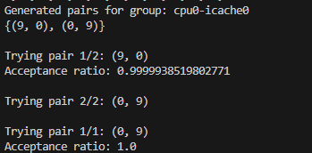

For each sliced trace, the possible causal pairs are calculated, and then the acceptance ratio is calculated for each pair applied to the trace, as discussed. and then a txt file is generated, and it all goes in a folder. for example,

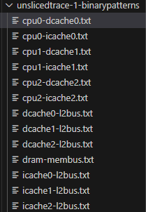**folder for the patterns for gem-5 snoop sliced traces**

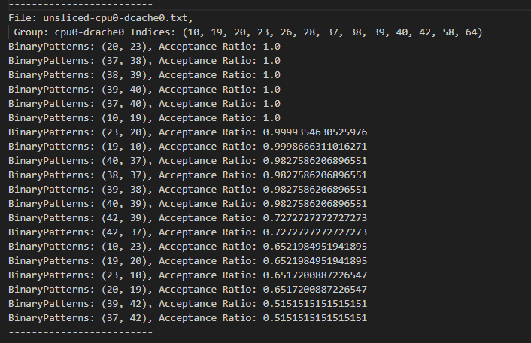

Component_binary_pattern

Given 948 local patterns txt, and the original unsliced trace (unslicedtrace.txt or snoopunsliced-RubelPrintFormat.jbl)

Applies all pairs on the original trace.

Output in componentpatterns.txt (descending order)

